When Labels Disagree — Master Research Blueprint
Oct 31, 2026 · @Farhan Aaqil

Project at a glance
When Labels Disagree: LabelTriage, Learning to Separate Annotation Error from Genuine Ambiguity and Training on Each Differently.
Field | Detail
Track | AIML Capstone / research-track submission
Area | Label noise, learning from crowds, uncertainty estimation, robust ML
Grounding | 2024–2026 work on human label variation (VariErr, LeWiDi 2025), multi-annotator learning (CROWDLAB) and noisy-label learning (CIFAR-10N / 10H)
Difficulty | 8 / 10
Plan | 8 phases over about 16 weeks, each closed by a go / no-go gate
Compute | About 90 T4 GPU-hours (free Kaggle / Colab tier is enough)
Version | 1.0, October 2026
Project owner: Farhan Aaqil Durrani. AI Engineer Intern @ Sydney Leads Digital Marketing. Final-Year B.Tech AI/ML, JPNCE Mahbubnagar.

1. Executive Summary
LabelTriage learns, for every annotation, whether a disagreement is a mistake or a genuine ambiguity, and then trains on each kind differently: mistakes are removed, ambiguity is kept as a soft label.
The field is split in two. Noisy-label methods (Confident Learning, CROWDLAB, DivideMix) treat all disagreement as noise to remove. Human-label-variation work (soft labels, the LeWiDi shared tasks) treats all disagreement as signal to keep. When five annotators say "dog, dog, dog, wolf, wolf", the first camp deletes the wolf votes and the second keeps them, whatever the image actually shows.
Evidence says neither global rule is right. To Aggregate or Not? found soft labels win on CIFAR-10N but majority vote wins on CIFAR-10H, because the two datasets differ in error rate and annotators per item. VariErr showed errors hide under label variation, and that standard error detectors separate them poorly.
This project makes three contributions:
- AmbiNoise, a benchmark with known error and known ambiguity. Real human vote distributions (CIFAR-10H, about 50 votes per image; ChaosNLI, 100 per item) supply genuine ambiguity. Controlled error processes, such as spammers, class swaps and misread instructions, are injected on top, so every annotation is labelled as error or variation.
- LabelTriage, a learned triage model. It reads disagreement patterns, such as whether the minority label is semantically close and whether nearby examples split the same way, then routes each item to a hard, soft or cleaned target.
- A harm analysis. Counterfactual retraining measures which disagreement patterns actually hurt generalisation, which directly answers the project's main question.
The project is very feasible: small datasets, ResNet-18 and DeBERTa-v3-base, about 90 T4 GPU-hours, and mature tools (cleanlab, Hugging Face). Results are tested over 3–5 seeds against pre-registered thresholds. A null result still counts: it would show that disagreement patterns do not predict harm beyond simple entropy.

2. Literature Landscape
Two research communities study the same disagreements with opposite assumptions, and almost no work connects their detection methods to their training methods.

2.1 Foundational techniques this project builds on
Technique (paper) | What it does | Where it is used here
Dawid–Skene model (Dawid & Skene, 1979) | Estimates each annotator's confusion matrix and the latent true label by EM | Annotator-reliability features; aggregation baseline
Soft-label training (Peterson et al., ICCV 2019) | Trains on the full human vote distribution (CIFAR-10H) and improves robustness | Soft-label baseline; the "keep ambiguity" route
Confident Learning (Northcutt et al., JAIR 2021) | Finds likely label errors from out-of-sample predicted probabilities | Error-detection feature and baseline
Dataset Cartography (Swayamdipta et al., EMNLP 2020) | Uses training dynamics to split data into easy, ambiguous and hard-to-learn regions | Training-dynamics feature group
AUM (Pleiss et al., NeurIPS 2020) | Area-under-margin score flags mislabelled examples | Training-dynamics feature group
CLIP / DINOv2 and sentence encoders | Frozen embeddings for neighbourhood and semantic-plausibility signals | Neighbourhood and plausibility features

2.2 Closely related work and what each leaves open
Paper (date) | Core contribution | What it leaves open
VariErr NLI (Weber-Genzel et al., ACL 2024) | First dataset separating annotation error from human label variation: 500 MNLI items, validity judgments on 1,933 explanations; existing error detectors trail GPT-4 and humans | Detection only; never uses the separation to train a better model. 500 items, NLI only.
CROWDLAB (Goh et al., 2022) | Combines a classifier with annotator votes to give consensus labels, quality scores and annotator ratings | Treats low agreement as low quality; has no notion of legitimate ambiguity
To Aggregate or Not? (Wei et al., KDD 2023) | Compares aggregation with soft labels on CIFAR-10N and CIFAR-10H | Picks one rule per dataset; shows the best rule flips but offers no per-example choice
CIFAR-10N / 100N (Wei et al., ICLR 2022) | Real human noisy labels, 3 annotators per CIFAR-10 training image | Ground truth is the original label; ambiguity and error are not separated
LeWiDi 2025 (Leonardelli et al., 2025) | Shared task on soft-label and per-annotator prediction across 4 datasets incl. VariErr | Treats all variation as signal to model; does not ask which variation hurts
Distributions In, Distributions Out (Singh, 2026) | Argues for soft-label training on CIFAR-10H-style data | Applies soft labels globally, including to erroneous votes
Revisiting Active Learning under Label Variation (2025) | Calls for decomposing observed label variation into signal and noise | A position and framework; no learned decomposition
From Noise to Signal to Selbstzweck (2025) | Position paper: telling HLV from error remains a practical challenge | Identifies the problem; no method
Data Maps and AUM (2020) | Separate ambiguous from hard-to-learn examples via training dynamics | Single labels only; VariErr found such methods underperform

3. The Research Gap
Disagreement is either deleted or kept wholesale; nobody learns, per example, which to do and then checks the effect on generalisation.
Identified gap (narrow enough to falsify in one semester)
- Treatment gap. Training methods apply one global rule to all disagreement: aggregate, soft-label or filter. We found no method that learns, per annotation, whether it is an error or legitimate variation and then routes the example to a different training target.
- Ground-truth gap. The only dataset with error-versus-variation labels is VariErr: 500 NLI items, 4 annotators. No image dataset has it, and none lets error rate and error type be varied while ambiguity stays real.
- Harm gap. Work on human label variation argues ambiguity is signal; noisy-label work argues disagreement hurts. No controlled study measures which disagreement patterns actually harm clean-test generalisation and calibration.
Why this gap is worth solving
- The best global rule flips between datasets. To Aggregate or Not? shows this on CIFAR-10N versus CIFAR-10H, so any fixed rule is wrong somewhere.
- Real annotation pipelines face it daily. Medical, content-moderation and preference data (RLHF) all mix sloppy errors with real disagreement.
- Highly buildable. Datasets are small and public; every model trains in minutes on a T4.
- Falsifiable. Either triage beats the best global rule at matched data, or it does not; either the triage model transfers to VariErr's real errors, or it does not.

4. Research Questions and Hypotheses
Four questions, each with a numeric threshold frozen in Phase 5 before any test-split result is seen.
ID | Research question | Hypothesis (pre-registered) | Falsified if
RQ1 | Can disagreement patterns separate annotation error from genuine ambiguity? | H1: Per-annotation error-detection AUROC is at least 0.85 on AmbiNoise and at least 0.70 on VariErr's real errors without training on VariErr. It beats annotator entropy alone by at least 0.10. | Gain over entropy alone is under 0.03, or VariErr AUROC is under 0.60
RQ2 | Does per-example triage improve generalisation over one global rule? | H2: At 20–40% injected error with 5 annotators per item, LabelTriage beats the best global rule by at least 1.5 clean-accuracy points, and is never more than 0.5 points below it in any setting. | The 95% CI of the gain over the best global rule includes 0 in the main setting
RQ3 | Which disagreement patterns harm generalisation? | H3: Removing true error annotations raises clean accuracy; collapsing true ambiguity to majority vote leaves accuracy flat but worsens calibration error (ECE) by at least 20% relative. | Collapsing ambiguity changes ECE by under 5%
RQ4 | Does triage keep human-like uncertainty on ambiguous items? | H4: On held-out ambiguous CIFAR-10H images, LabelTriage's KL divergence to the human vote distribution is within 10% of the soft-label baseline and at least 30% below majority vote. | KL is not significantly below majority vote
Primary hypothesis. H2 is the headline: a learned per-example policy is worth more than the best fixed rule, which is the user-facing promise of the project.

5. Proposed System: LabelTriage
LabelTriage turns every annotation into a feature vector describing its disagreement pattern, scores it as error or variation, and builds each example's training target from the votes that survive.

5.1 Core idea
- Describe each annotation's disagreement pattern with five cheap signal groups: vote statistics, annotator reliability, semantic plausibility of the chosen class, how nearby examples are labelled, and training dynamics.
- Score each annotation. A small triage model outputs p(error) per annotation. It is trained on AmbiNoise, where the answer is known.
- Route each example to one of three targets:
  - Clear: surviving votes agree, so train on a hard label.
  - Ambiguous: surviving votes still split across plausible classes, so train on their soft distribution.
  - Unreliable: few votes survive, so down-weight the example.
- Train the classifier on the routed targets with a weighted soft cross-entropy.
- Measure harm by retraining with each disagreement category removed or collapsed, one at a time.
The five-annotator example plays out like this. Three say dog and two say wolf. If CLIP finds wolf plausible and nearby images split the same way, the wolf votes are kept and the image trains as 60% dog, 40% wolf. If the two wolf votes come from annotators who are unreliable elsewhere and wolf is implausible, they are dropped and the image trains as dog.

5.2 AmbiNoise, the benchmark
AmbiNoise starts from datasets with many human votes per item, so the ambiguity is real. It then samples K annotators per item and corrupts some of their votes with known error processes. Every annotation is therefore labelled as error or variation, at error rates and types the experimenter controls.

6. Novelty and Contribution Claims
Each ingredient exists separately; the novelty is joining detection to per-example training choices, and measuring harm with real ambiguity held fixed.

6.1 How this differs from the closest prior work
vs. VariErr. VariErr defines and detects error versus variation in NLI, but stops at detection. LabelTriage uses the separation to change training, and adds images, controllable error rates and a transfer test back onto VariErr's real errors.
vs. CROWDLAB and Confident Learning. These score label quality, so a genuinely ambiguous image looks low-quality and gets filtered. LabelTriage has an explicit ambiguity route and keeps those votes as soft targets.
vs. soft-label and LeWiDi systems. These keep every vote, including errors. LabelTriage keeps only the votes it judges plausible.
vs. To Aggregate or Not?. That study picks one rule per dataset. LabelTriage picks per example, and is tested exactly where the best global rule flips.
Claim | Why it is new
AmbiNoise: real ambiguity plus controlled, labelled errors, for images and NLI | VariErr is the only error-versus-variation dataset (500 NLI items); no image analogue exists
Per-annotation triage from disagreement-pattern features | Prior detectors score items or labels, not individual votes, and do not model ambiguity as a separate outcome
Three-route target construction (hard, soft, down-weighted) | Prior training pipelines apply one global rule
Transfer test: train on synthetic errors, test on VariErr's real errors | Shows whether learned patterns reflect real annotation behaviour
Counterfactual harm analysis | First controlled measurement of which disagreement types hurt accuracy versus calibration

7. System Architecture
LabelTriage is a pipeline of small, separately testable stages; only the final classifier is a deep network trained per run.
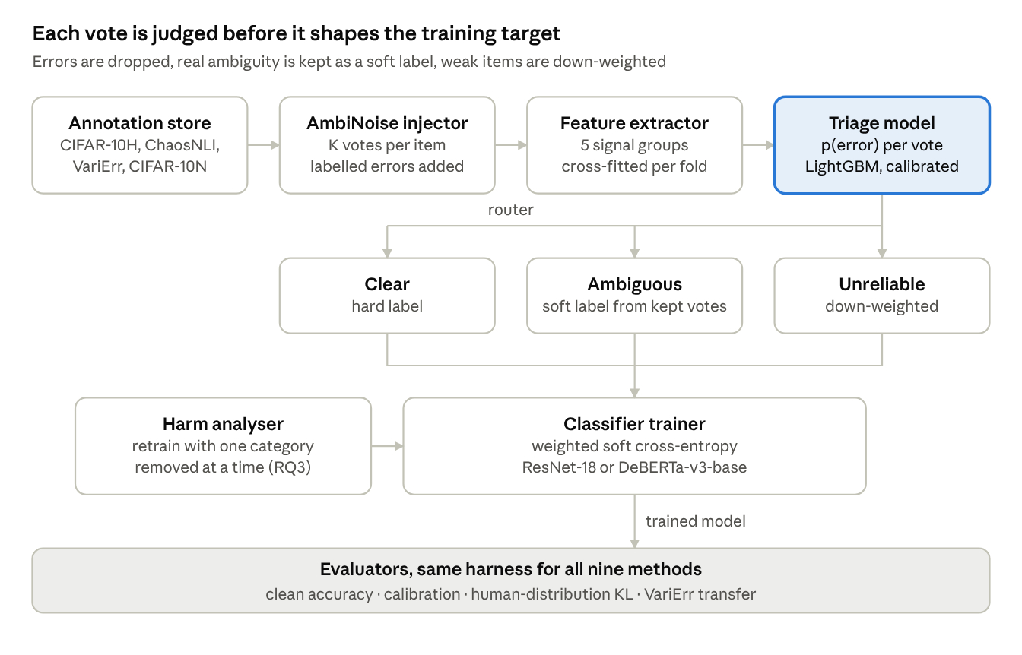
LabelTriage architecture · from votes to routed targets
The harm analyser reuses the same trainer with one disagreement category removed, so every comparison shares data, seeds and budget.

7.1 Components
Component | Role | Key setting
Annotation store | Items, annotator IDs and votes in one table | CIFAR-10H, ChaosNLI, VariErr, CIFAR-10N
AmbiNoise injector | Samples K annotators per item and corrupts votes with labelled error processes | K in {3, 5, 10}; error rate in {10%, 20%, 40%}; 4 error types
Feature extractor | Builds a disagreement-pattern vector per annotation from 5 signal groups | 5-fold cross-fitting so no item scores itself
Triage model | Predicts p(error) per annotation | LightGBM; isotonic calibration on validation
Router | Builds each item's target: hard, soft or down-weighted | Thresholds tuned on validation only
Classifier trainer | Trains on routed targets with weighted soft cross-entropy | ResNet-18 (images), DeBERTa-v3-base (NLI)
Harm analyser | Retrains with one disagreement category removed or collapsed at a time | Same seeds and budget as main runs
Evaluators | Clean accuracy, calibration, human-distribution match, transfer to VariErr | Same harness for every method

7.2 Flow
- Votes enter the store; for AmbiNoise, the injector adds labelled errors.
- The feature extractor scores every annotation on the 5 signal groups, cross-fitted.
- The triage model outputs p(error) per annotation.
- The router builds each item's target from surviving votes.
- The classifier trains on routed targets; evaluators score it on clean, shifted and human-distribution tests.
- The harm analyser repeats step 5 with categories removed, to answer RQ3.

8. Technical Formulation
The right training target for an item is the clean human vote distribution; majority vote and soft labels each miss it in a different regime, and triage aims to recover it.

8.1 Why one global rule must fail somewhere
Let p* be item i's clean human distribution, and suppose a share ε of its votes are errors drawn from distribution u. The observed vote distribution is then:
q^{obs}_i = (1-\varepsilon_i)\, p^{*}_i + \varepsilon_i\, u_i
Observation 1. A soft label is off from p* by ε · ‖u − p*‖, which grows with the error rate. A majority-vote label is off by ‖onehot − p*‖, which grows with genuine ambiguity; with few annotators, a couple of error votes can also outvote the true class. Which rule wins therefore depends jointly on error rate, ambiguity and K. That is consistent with To Aggregate or Not?: soft labels won with 3 noisy votes per image on CIFAR-10N, while majority vote won with about 50 low-noise votes on CIFAR-10H. A triage target that removes detected error votes approaches p* in every regime.

8.2 Disagreement-pattern features
Each annotation a on item i, voting for class y, gets a feature vector from five groups:
Group | Signals | Intuition
G1 Vote statistics | Item vote entropy; share of votes for y; rank of y; K | Lone dissent differs from an even split
G2 Annotator reliability | Dawid–Skene accuracy of annotator a; CROWDLAB annotator score; agreement on high-consensus items | Errors cluster in unreliable annotators
G3 Semantic plausibility | Frozen CLIP zero-shot p(y given image), and its ratio to the majority class; for NLI, a pretrained MNLI model's p(y) | Dog versus wolf is plausible; dog versus truck is not
G4 Neighbourhood consistency | Share of the 20 nearest neighbours (DINOv2 or sentence embeddings) whose votes also include y | Real ambiguity recurs among similar items; errors do not
G5 Training dynamics | Data-map confidence and variability, and AUM for label y, from a 5-fold cross-fitted probe model | Errors are learned late or never

8.3 Triage labels and model
An annotation is labelled an error if it was injected by AmbiNoise, or if its class received under 10% of the item's full vote pool (about 50 votes in CIFAR-10H, 100 in ChaosNLI). The second rule catches native errors already in the human data. LightGBM learns e = p(error) from the features, calibrated with isotonic regression on validation.

8.4 Routing and loss
Surviving-vote weights and the cleaned distribution are:
w_{ia} = 1 - e_{ia}, \qquad q_i(c) = \frac{\sum_a w_{ia}\,\mathbb{1}[y_{ia}=c]}{\sum_a w_{ia}}, \qquad n_i = \sum_a w_{ia}
- Unreliable if the effective vote count n_i is below ν: target q_i, sample weight n_i / K.
- Clear if the entropy of q_i is at most h₀: target is the one-hot argmax of q_i, weight 1.
- Ambiguous otherwise: target q_i, weight 1.
\mathcal{L} = \sum_i \omega_i \, \mathrm{CE}\big(\tilde{q}_i,\, f_\theta(x_i)\big)
Starting values, tuned on validation only: ν = 1.5 votes; h₀ = 0.3 nats; hard drop when e > 0.8 as an ablation of soft weighting.

8.5 Harm analysis (RQ3)
Using AmbiNoise's known labels, the classifier is retrained under four counterfactual datasets at equal size and seeds: errors removed; ambiguity collapsed to majority; both; neither. The accuracy and ECE differences attribute harm to each category. Feature-group ablations on the triage model then show which disagreement patterns predict that harm.

9. Datasets, Benchmark Design and Evaluation Protocol
Evidence comes in three tiers: controlled AmbiNoise for images and NLI, real human noise on CIFAR-10N, and real error labels on VariErr for transfer.

9.1 Datasets
Dataset | What it gives | Role
CIFAR-10H | About 50 human votes for each of the 10,000 CIFAR-10 test images | Real image ambiguity; base of AmbiNoise-10H. Split 7,000 train / 1,000 validation / 2,000 human-distribution test.
CIFAR-10 train set (50,000) and CIFAR-10.1 (2,000) | Clean single labels on unseen images | Clean-accuracy and shift tests for AmbiNoise-10H models
CIFAR-10-C | Corrupted CIFAR-10 images | Robustness test
CIFAR-10N | 3 real human labels per CIFAR-10 training image | Real-noise downstream test, evaluated on CIFAR-10.1
ChaosNLI (SNLI and MNLI parts) | 100 human votes per item, about 3,100 items | Real NLI ambiguity; base of AmbiNoise-NLI. Split 70 / 10 / 20.
VariErr NLI | 500 MNLI items, 4 annotators, real error-versus-variation judgments | Transfer test only; never used for training or tuning

9.2 AmbiNoise construction
Element | Specification
Annotators per item | Sample K real votes from the full pool; K in {3, 5, 10}; main setting K = 5
Error rate | 10%, 20% or 40% of sampled votes corrupted
Error types | Spammer (uniform random class); systematic swap (a fixed class pair, e.g. cat and dog, or entailment and contradiction); lazy (always the most common class); plausible-wrong (the model's second-ranked class, the hardest case)
Annotator structure | Errors are tied to simulated annotator IDs with their own error rates, so annotator-reliability features have something to find
Native errors | A real vote whose class got under 10% of the item's full pool is also labelled an error
Sanity checks | The clean votes' distribution stays close to the full-pool distribution (median KL under 0.05); an oracle triage recovers clean accuracy
Statistical power, stated up front
- The 4 headline settings (each error type at 20%, K = 5) run 5 seeds; all other settings run 3.
- Clean-test accuracy on 50,000 images has a standard error near 0.2 points, so seed variance dominates. The Phase 5 pilot measures it and sets a minimum detectable effect.
- H2 is tested across the 12 settings (4 error types × 3 rates) with a paired Wilcoxon test, plus per-setting bootstrap 95% CIs.
- H1–H4 use Holm–Bonferroni correction.
- Limits, stated in the report: AmbiNoise-NLI test sets hold about 600 items (CIs near ±1.5 points); VariErr has 500 items (AUROC CIs near ±0.05); synthetic errors may be easier than real ones, which is exactly why the VariErr transfer test exists.

10. Baselines
Nine methods share the same data, backbone, epochs and seeds; the entropy rule and the oracle bracket what learning can add.
Baseline | Description | What it tests
Majority vote | Hard label from the most common vote | The default "collapse" rule
Soft labels | Train on the raw vote distribution | The default "keep everything" rule
Dawid–Skene | EM-aggregated label using annotator confusion matrices | Classic crowd aggregation
CROWDLAB | cleanlab.multiannotator consensus label, with low-quality items filtered | Strongest open multi-annotator quality method
Confident Learning | Prune likely errors from majority-vote labels, then retrain | Single-label error detection
DivideMix (images) / Co-teaching (NLI) | Noise-robust training on majority-vote labels | Robust training that ignores annotator structure
Entropy-weight rule | Sample weight decreases with vote entropy; no learning | The naive "disagreement means unreliable" rule; does learning beat it?
Oracle triage | Routes using the true error labels | Upper bound for any triage method
LabelTriage (proposed) | Learned per-annotation triage plus three-route targets | The contribution
Ablations (3 seeds each): each feature group removed in turn; hard drop versus soft weighting; two routes (no unreliable route) versus three; LightGBM versus MLP triage model; frozen DINOv2 plus MLP head as a second image backbone.

11. Evaluation Metrics
Metrics cover the triage decision itself, the trained classifier, and the harm attribution, one family per research question.
Family | Metric | Definition
Triage (RQ1) | Error-detection AUROC and AUPRC | Per annotation, against AmbiNoise labels and, for transfer, VariErr's real judgments
Triage (RQ1) | Gain over entropy | AUROC of LabelTriage minus AUROC of vote entropy alone
Triage (RQ1) | Ambiguity recall | Share of truly ambiguous items routed to the soft target
Generalisation (RQ2) | Clean accuracy | On the CIFAR-10 train set (50,000) and CIFAR-10.1; ChaosNLI test items scored against their 100-vote majority
Generalisation (RQ2) | Robust accuracy | Mean accuracy over CIFAR-10-C corruptions
Generalisation (RQ2) | Regret to best global rule | Accuracy gap to whichever of majority vote and soft labels is better in that setting
Calibration (RQ3, RQ4) | ECE and NLL | Expected calibration error (15 bins) and negative log-likelihood on clean test
Human alignment (RQ4) | KL and Jensen–Shannon divergence | Model's predicted distribution versus the full human vote pool on the 2,000 held-out CIFAR-10H images and ChaosNLI test items
Human alignment (RQ4) | LeWiDi soft metrics | Manhattan and Wasserstein distance, for comparability with LeWiDi 2025
Harm (RQ3) | Accuracy and ECE deltas | Change versus the "neither removed" counterfactual, per disagreement category

12. Tech Stack and Compute Budget
The whole study fits in about 90 free-tier T4 GPU-hours, because every training set is under 50,000 examples and most are under 10,000.

12.1 Stack
- Core: Python 3.11, PyTorch 2.x, Hugging Face Transformers and Datasets.
- Models: ResNet-18 trained from scratch (images); DeBERTa-v3-base fine-tuned (NLI); frozen CLIP ViT-B/32 and DINOv2 ViT-S/14 for features; a public MNLI model for NLI plausibility.
- Label-quality tools: cleanlab (Confident Learning, CROWDLAB via cleanlab.multiannotator); crowd-kit for Dawid–Skene; official DivideMix and Co-teaching code.
- Triage: LightGBM, scikit-learn isotonic calibration, FAISS for nearest neighbours.
- Tracking: Hydra configs, Weights & Biases free tier, a git tag freezing the pre-registration in Phase 5.
- Demo: an interactive Disagreement Explorer (Streamlit or React): scatter of items by vote entropy and p(error), colour-coded by route, with click-through to the image, its votes and the reasons behind its route.

12.2 Compute budget
Workload | Runs | Est. T4 GPU-hours
AmbiNoise-10H main grid (9 methods × 12 settings × 3 seeds) | 324 | 24
2 extra seeds for the 4 headline settings | 72 | 5
Annotator-count sweep, K = 3 and 10 (5 methods) | 120 | 9
AmbiNoise-NLI (9 methods × 6 settings × 3 seeds) | 162 | 11
CIFAR-10N real-noise runs (9 methods × 3 seeds) | 27 | 14
Feature extraction and cross-fitted probe models | — | 3
Harm counterfactuals (4 datasets × 4 settings × 3 seeds) | 48 | 3
Ablations | about 96 | 7
Buffer (15%) | — | 12
Total |  | about 88
Kaggle's free quota of about 30 GPU-hours a week covers this in 3 weeks of Phases 5–7. Phase 1 times one run of each type to confirm the estimates.

13. Eight-Phase Plan
Eight two-week phases, about 16 weeks in total; each ends at a gate that decides whether to proceed, adjust or take the fallback.
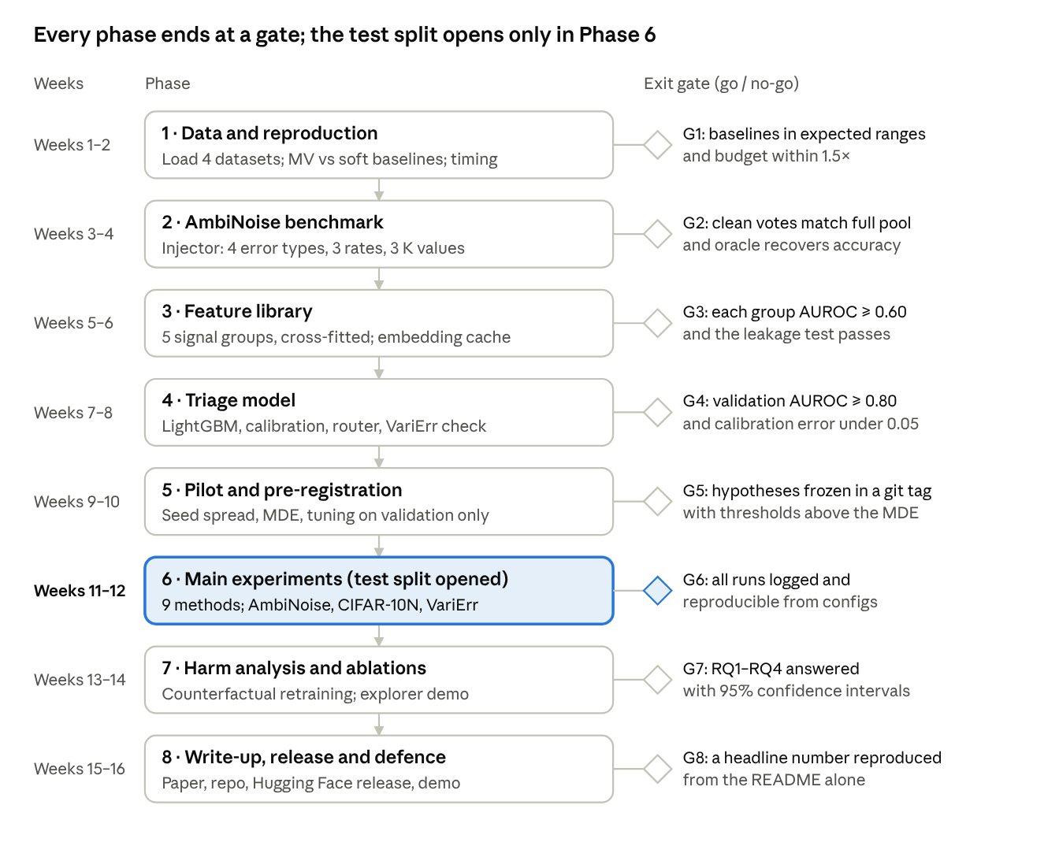
Eight-phase roadmap · 16 weeks, 8 gates
Phase 6 is the only phase that touches the test splits; everything before it is built and tuned on train and validation data.
Phase | Weeks | Key work | Deliverable | Exit gate (go / no-go)
1. Data and reproduction | 1–2 | Load CIFAR-10H, CIFAR-10N, ChaosNLI, VariErr. Reproduce majority vote versus soft labels on CIFAR-10H. Time one run of each type. | Data loaders; baseline numbers; compute check | Baselines land in expected ranges; budget confirmed within 1.5×
2. AmbiNoise benchmark | 3–4 | Build the injector (4 error types, 3 rates, 3 K values), native-error rule, annotator IDs, splits. | AmbiNoise-10H and AmbiNoise-NLI with a dataset card | Clean-vote distributions match the full pool (median KL under 0.05); oracle triage recovers clean accuracy
3. Feature library | 5–6 | Implement the 5 feature groups with 5-fold cross-fitting; cache CLIP, DINOv2 and sentence embeddings. | Tested feature pipeline | Each group alone reaches AUROC 0.60+ on validation; leakage test passes
4. Triage model | 7–8 | Train and calibrate LightGBM; first VariErr transfer check; build the router. | Calibrated triage model and router | Validation AUROC at least 0.80; calibration error under 0.05
5. Pilot and pre-registration | 9–10 | One-seed pilot of all 9 methods; measure seed spread; compute the minimum detectable effect; tune ν and h₀ on validation. | Frozen configs and hypotheses in a git tag | Every threshold in H1–H4 is above the minimum detectable effect
6. Main experiments | 11–12 | Full grids on AmbiNoise-10H, AmbiNoise-NLI and CIFAR-10N; K sweep; final VariErr transfer. Test splits opened once. | Results tables with 95% CIs | All runs logged and reproducible from configs
7. Harm analysis and ablations | 13–14 | Counterfactual retraining (RQ3); feature-group and routing ablations; error analysis of misrouted items; Disagreement Explorer demo. | Harm attribution, ablation table, explorer | All four research questions answered with CIs
8. Write-up, release and defence | 15–16 | Workshop-format paper; public repo; AmbiNoise on Hugging Face; slides and demo. | Paper, repo, dataset release, defence deck | One headline number reproduced from the README alone
Phases 2 and 3 can overlap: the embedding cache in Phase 3 does not depend on the injector.

14. Risk Register
The main scientific risk is that synthetic errors are easier than real ones; the VariErr transfer test and the plausible-wrong error type exist to catch it.
Risk | Likelihood | Mitigation
Synthetic errors are easier to spot than real ones, inflating triage scores | High | Plausible-wrong error type as a stress test; VariErr transfer reported separately; CIFAR-10N real-noise runs
Semantic-plausibility features (CLIP) leak the answer, since CLIP knows CIFAR classes | Medium | Report triage with and without G3; the second backbone uses DINOv2 features, not CLIP
Gains appear only at high error rates | Medium | H2 includes a "never worse by more than 0.5 points" clause, so a regime-robust result still counts
Native errors in CIFAR-10H mislabel some "variation" votes | Medium | 10%-of-pool rule; sensitivity analysis with 5% and 15% cut-offs
VariErr's 4-annotator, NLI-only setting differs from AmbiNoise | Medium | Train the NLI triage model with K = 3 and 5 to match; report the gap honestly as a limitation
Feature leakage through cross-fitting mistakes | Low | Leakage unit test: shuffled labels must give AUROC near 0.5
DivideMix is slow or unstable on 7,000 images | Low | Fall back to Co-teaching on images too; document the swap
A close paper appears mid-project (this area is active) | Medium | Weekly arXiv alert on "label variation error"; preprint right after Phase 6; AmbiNoise stays a contribution either way
LabelTriage does not beat the best global rule | Medium | Pre-registered null path: AmbiNoise plus the harm analysis are still publishable

15. Expected Contributions
Five contributions, at least three of which hold whether or not LabelTriage wins.
- AmbiNoise (holds either way). The first image benchmark, plus an NLI one, where every annotation is labelled error or variation at controlled rates and types. Released on Hugging Face.
- A harm map of disagreement (holds either way). Which disagreement types cost accuracy and which cost calibration, measured by counterfactual retraining.
- LabelTriage. A per-annotation triage model and three-route training pipeline, compared against nine methods including an oracle.
- A transfer result (holds either way). Whether patterns learned from synthetic errors detect VariErr's real errors, which tells the field whether synthetic noise is a valid proxy.
- Observation 1. A simple account of why the best global rule flips between datasets, tested across error rate, ambiguity and annotator count.
If H2 holds and VariErr transfer reaches 0.70 AUROC, the work suits a main-conference data-centric ML or NLP track. Otherwise it suits a workshop such as NLPerspectives, with AmbiNoise and the harm map as the core.

16. Blueprint Scorecard
The blueprint scores about 8.8 out of 10 overall; it trades some novelty for very high feasibility, which makes it the safer of your two capstone candidates.
Criterion | Rating | Why it earns this rating | What would lower it
Research gap | 8.5 / 10 | VariErr stops at detection; position papers in 2025 call the separation an open challenge; no per-example treatment exists | An unseen paper already routing ambiguous and erroneous votes differently
Novelty | 8 / 10 | AmbiNoise, the three-route pipeline and the harm map are new; the individual features are known | LabelTriage gaining nothing over CROWDLAB plus soft labels
Feasibility | 9.5 / 10 | Public datasets under 50,000 items, minute-long runs, about 90 free T4 hours | Compute estimate off by more than 2× in Phase 1
Implementation clarity | 9.5 / 10 | Every stage is a small, testable module built on cleanlab, crowd-kit and Hugging Face | Leakage in cross-fitting going unnoticed
Evaluation rigour | 9 / 10 | Oracle and naive-rule brackets, 9 baselines, real-noise and real-error transfer tests, pre-registration, Holm correction | Reporting only synthetic results
Impact and publishability | 8 / 10 | Directly relevant to medical labels and RLHF preference data; benchmark is useful either way | Gains limited to high synthetic error rates
Difficulty | 8 / 10 | Manageable, as intended; harder than a standard noisy-label study because of the benchmark and harm analysis | —
What would lift it past 9:
- Add a preference dataset (e.g. HelpSteer2) as a third domain, which ties the work to RLHF data quality.
- Collect a small real image ground truth: about 300 CIFAR-10N disagreements re-judged by 3 people with explanations, VariErr-style.
- Turn Observation 1 into a formal regret bound for global rules versus triage.

17. Deliverables Checklist
- ☐ AmbiNoise-10H and AmbiNoise-NLI with injector code and dataset card, on Hugging Face
- ☐ Feature library (5 groups) with cross-fitting and a leakage test
- ☐ Calibrated LabelTriage model and router
- ☐ All nine methods benchmarked on AmbiNoise, CIFAR-10N and ChaosNLI, 3–5 seeds each
- ☐ VariErr transfer results
- ☐ Harm-analysis counterfactuals and the ablation table
- ☐ Disagreement Explorer interactive demo
- ☐ Pre-registration tag in the repository, frozen before Phase 6
- ☐ Workshop-format paper with an explicit limitations section
- ☐ Public repository whose README credits cleanlab, crowd-kit, CIFAR-10H, CIFAR-10N, ChaosNLI and VariErr
- ☐ Defence slide deck and live demo

18. Glossary
Term | Meaning
Annotation error | A label given for an invalid reason: a misclick, misread instruction, spam or carelessness
Human label variation (HLV) | Disagreement for valid reasons: the item is genuinely ambiguous or open to interpretation
Majority vote | Training label set to the most common vote
Soft label | Training target set to the share of votes each class received
Triage | Deciding, per annotation, whether it is an error, and routing the example to a hard, soft or down-weighted target
AmbiNoise | This project's benchmark: real vote distributions plus injected, labelled errors
Native error | A real vote whose class got under 10% of the item's full vote pool
Dawid–Skene | A classic EM model of each annotator's confusion matrix
Cross-fitting | Computing a feature for each fold with a model trained on the other folds, so no item scores itself
AUROC | Probability a random error scores higher than a random non-error
ECE | Expected calibration error: gap between predicted confidence and actual accuracy
KL divergence | How far the model's predicted distribution is from the human vote distribution
Pre-registration | Freezing hypotheses, thresholds and configs before seeing test results

19. References
- L. Weber-Genzel, S. Peng, M.-C. de Marneffe, B. Plank. VariErr NLI: Separating Annotation Error from Human Label Variation. ACL 2024 / arXiv:2403.01931.
- H. W. Goh, U. Tkachenko, J. Mueller. CROWDLAB: Supervised Learning to Infer Consensus Labels and Quality Scores for Data with Multiple Annotators. NeurIPS 2022 HILL Workshop.
- J. Wei et al. To Aggregate or Not? Learning with Separate Noisy Labels. KDD 2023.
- J. Wei, Z. Zhu, H. Cheng, T. Liu, G. Niu, Y. Liu. Learning with Noisy Labels Revisited: A Study Using Real-World Human Annotations. ICLR 2022.
- J. C. Peterson, R. M. Battleday, T. L. Griffiths, O. Russakovsky. Human Uncertainty Makes Classification More Robust. ICCV 2019.
- Y. Nie, X. Zhou, M. Bansal. What Can We Learn from Collective Human Opinions on Natural Language Inference Data? (ChaosNLI). EMNLP 2020.
- E. Leonardelli et al. LeWiDi-2025 at NLPerspectives: The Third Edition of the Learning with Disagreements Shared Task. 2025.
- A. Singh. Distributions In, Distributions Out: The Case for Soft-Label Training. arXiv, 2026.
- Revisiting Active Learning under (Human) Label Variation. arXiv:2507.02593, 2025.
- Position: From Noise to Signal to Selbstzweck — Reframing Human Label Variation in the Era of Post-training in NLP. arXiv:2510.12817, 2025.
- C. Northcutt, L. Jiang, I. Chuang. Confident Learning: Estimating Uncertainty in Dataset Labels. JAIR 2021.
- S. Swayamdipta et al. Dataset Cartography: Mapping and Diagnosing Datasets with Training Dynamics. EMNLP 2020.
- G. Pleiss, T. Zhang, E. Elenberg, K. Q. Weinberger. Identifying Mislabeled Data using the Area Under the Margin Ranking. NeurIPS 2020.
- J. Li, R. Socher, S. C. H. Hoi. DivideMix: Learning with Noisy Labels as Semi-supervised Learning. ICLR 2020.
- B. Han et al. Co-teaching: Robust Training of Deep Neural Networks with Extremely Noisy Labels. NeurIPS 2018.
- A. P. Dawid, A. M. Skene. Maximum Likelihood Estimation of Observer Error-Rates Using the EM Algorithm. Journal of the Royal Statistical Society C, 1979.
- A. Uma, T. Fornaciari, D. Hovy, S. Paun, B. Plank, M. Poesio. Learning from Disagreement: A Survey. JAIR 2021.
- B. Plank. The "Problem" of Human Label Variation: On Ground Truth in Data, Modeling and Evaluation. EMNLP 2022.

20. Attribution, Originality and Project Ownership
Declaration
This research blueprint, including the literature synthesis, the identification of the per-example treatment gap, the AmbiNoise benchmark design and the full LabelTriage system design, is authored and owned by Farhan Aaqil Durrani.
All cited works remain the intellectual property of their authors and institutions (Section 19). This document proposes original, derivative research that builds on their published, open findings. VariErr is acknowledged as the closest prior work and is credited and used as a transfer test.
Field | Detail
Project owner | Farhan Aaqil Durrani
Role | AI Engineer Intern @ Sydney Leads Digital Marketing
Affiliation | Final-Year B.Tech AI/ML, JPNCE Mahbubnagar
Version | 1.0, October 2026

